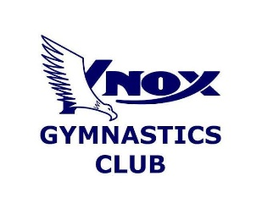

Knox

Gymnastics

Knox Gymnastics Club Version 3.3

November TERM 4 2021

Helping Knox Gymnastics Families Return to Sport in a Covid Safe environment

**Family Handbook**

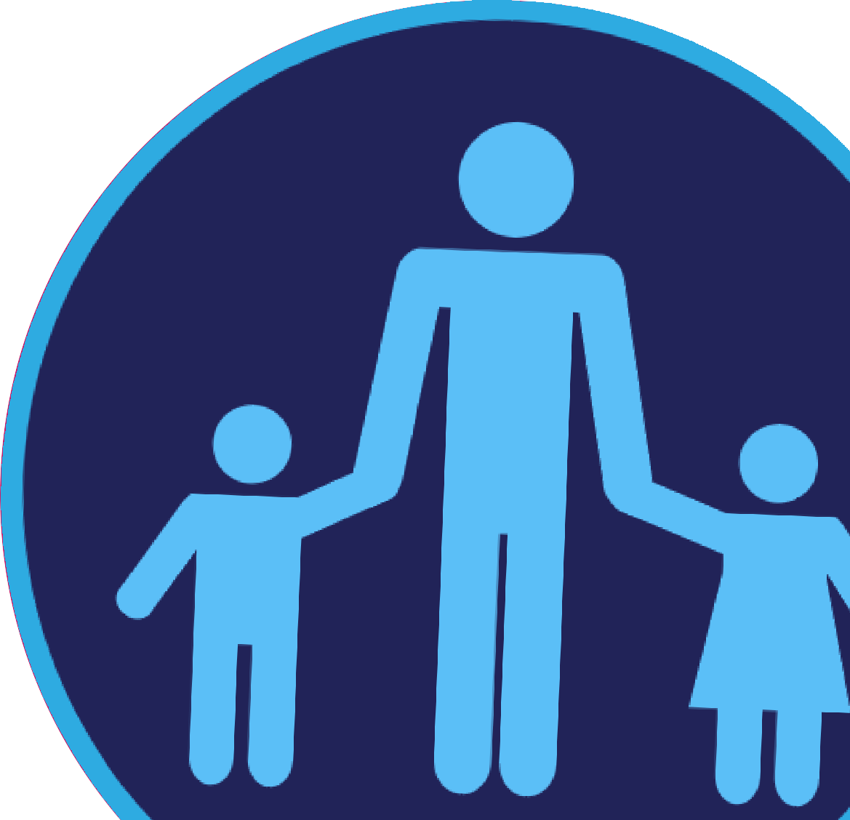

The impact of COVID-19 has continued to greatly impact gymnastics clubs in Victoria –

However, our commitment to the safety and wellbeing of all gymnastics families

has not wavered.

Knox Gymnastics Club have a responsibility to ensure the health, safety, and wellbeing

of gymnasts, volunteers and employees which includes their physical and mental wellbeing.

To ensure that we are looking after all our staff and members, changes have been

made to how gymnastics classes operate.

This document highlights some general changes you can expect. We will continue to update you with additional details to best suit our community and comply with Government regulations.

If you are unsure of any of the information provided in this handbook, please do not hesitate to contact us.

**These guidelines can be subject to change.**

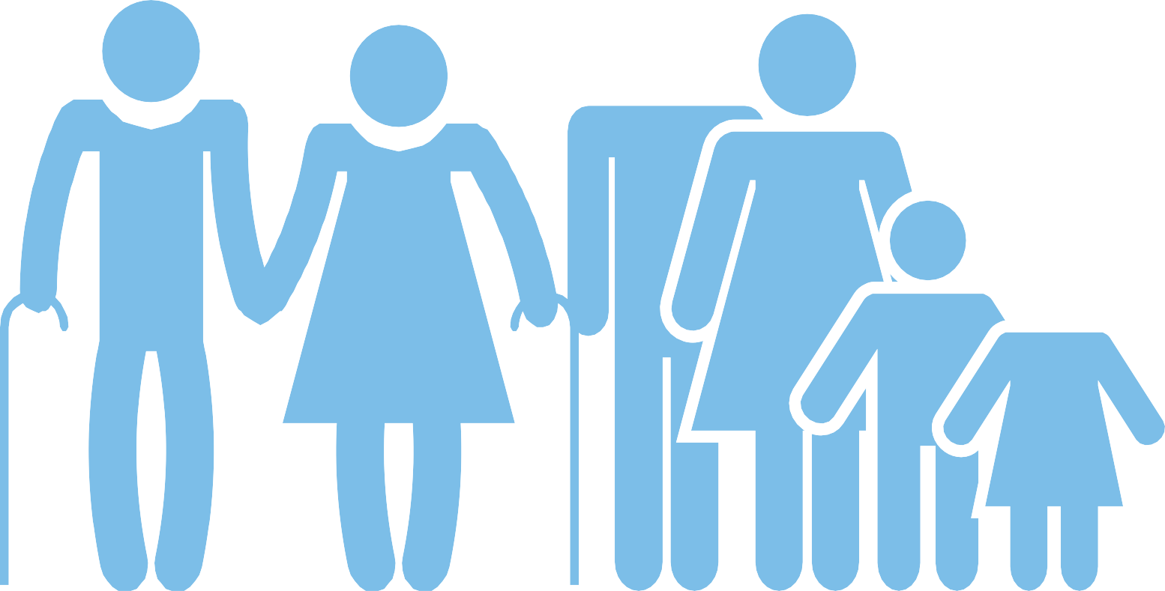

Let’s keep our

COVIDSafe

Gymnastics Club

Daily Health Check In / QR Code Scan In

You will be asked upon entry if you feel well. If you present with any flu like symptoms, you will be asked to not enter our facilities and follow up with necessary testing.

Knox Gymnastics require all participants / parents / carers to check-in using the Service Victoria QR code App.

All gymnasts will need to be scanned in on a mobile device, QR scan details are located at each entry.

**This is mandatory for all gymnasts coming into our facilities and proof of check in must be shown to our covid safety officer.**

Gymnasts/parents/carers 16+ will need to provide their proof of being fully vaccinated (This includes adult gymnasts too).

Drop, Train, Leave

We request only one parent or carer per child is in attendance when dropping the gymnast off to training.

**For Kindergym members, please refer to more specific details further in this handbook.**

Parents are asked to NOT enter the facility to spectate. The only exception for this is for parents who have a child attending their first trial session. Parents will be allowed to watch their child from the office window seating but must be double vaccinated with proof of certificate. This is to provide the best training environment for our gymnasts and reduce the risk of contamination. Please accompany your child to the check-in point, and our coaching team will greet you upon arrival. We ask that you meet them at the exit door to take them home. **We ask that gymnasts do not enter the facility until invited inside by our coaching team.** Again, our coaching team will be at the doors to farewell our gymnasts. Please refer to the FAQ at the back for more details regarding coming into our facility.

The drop off point is located at the carpark entry door at the carpark side of the building. This will be clearly sign-posted. We ask that you accompany your child to the check-point, ensure you follow social distancing and stand 1.5 metres away from others and wear a mask at all times. Gymnasts aged 13 years and older are not required to be accompanied by an adult but must still check in.

The customer service/administration area is now outside under the gazebo on the driveway. We ask that people social distance and stand 1.5m apart when queuing for customer service.

Where possible we ask all accounts to be paid via direct transfer or credit card over the phone.

***All visitors/customers to our administration area will need to register attendance with the QR code.***

In the event we need to contact you, your personal contact details with the club MUST be up to date.

You can log in at any time on the customer portal and update your details.

Wear clean clothes

We encourage you to make sure your child arrives in clean and appropriate attire ready for training. Where possible, gymnasts should avoid wearing their school clothes to training after long durations in contact with other individuals and where possible contamination may have occurred. Please arrive already changed ready to train.

Restrictions are in place regarding shared amenities. Toilet facilities are for gymnasts only and are limited to one person at a time. The shower area will be out of bounds.

Listen to your Coach

Children are adapting to the changes within society at the same time adults are, however, there can be differing expectations within different environments which makes it challenging for children to adapt to change at the pace required.

Prior to attending class talk to your child about some of the potential changes that may have been implemented within the club. Encourage them to listen to the coach and follow instructions as directed.

Bring with you

**For ALL gymnasts;**

* Face masks are required for children in grade 3 and above at all times when not doing physical activities. When gymnasts are on the apparatus the mask can be taken off.
* Face masks will be required if social distancing cannot be maintained, please bring along your face masks at all times.
* Clearly named FULL drink bottle (water only) Drink tap is available to fill up water bottles but the drinking fountain is not to be used.

**For competitive gymnasts;**

* BYO - Resistance bands, ankle weights, foam rollers, spiky balls, high bar loops, water spray bottle for grips or as directed by your coach.

Before Arrival

The class structure is different

Social distancing, venue restrictions, equipment spacing, cleaning procedures, and the financial impact of COVID-19 presents a multitude of challenges for gymnastics operators which have necessitated certain decisions to maintain program delivery.

**All classes will finish 5 minutes earlier to complete end of class procedures to meet on time at the designated pick- up point. Please ensure you are on time for pick up so our team can attend to the next class starting.**

Knox Gymnastics will communicate any significant change to our community. If you have any concerns speak to our Management Team regarding the changes.

All Covid Safety Officers, coaching staff and management have completed online Covid-19 infection control training and are fully vaccinated.

Skill training will be different and focus on the safe development of skills

Safe skill development within gymnastics requires significant physical preparation and regular use of safety apparatus to aid development. Apparatus circuits and equipment will be spaced out to maintain the required 1.5 metre safe distance.

Knox Gymnastics will be implementing the Gymnastics Australia ‘Return to Training Guidelines’ plan to ensure gymnasts have a progressive return whilst avoiding overload and injury. This plan is likely to be underpinned by State and National resources and will be dependent on the level of the gymnast.

Parents can be rest assured that coaches will continue to guide gymnasts through safe skill development in a time-frame appropriate with the gymnast’s condition, ability, and training environment.

Physical contact is restricted, but your coach will spot for safety

For the large proportion of gymnastics, the sport can be regarded as non-contact and therefore adheres to social distancing principles.

Knox Gymnastics will be limiting contact between gymnasts and/or between gymnasts and coaches wherever possible including avoiding any assisted stretching. Your coaches are still likely to engage in appropriate spotting as a necessary aspect for safe skill development, however, should be developing habits of short contact periods, or, avoiding contact if unnecessary.

**All gymnasts are expected to follow any new instructions as directed by Club Coaches**

**and Management.**

During Class

Hand washing/santising and cleaning requirements

Like all businesses, hygiene procedures will be in place within our club. Your child will be required to santise their hands upon entry and regularly encouraged to santise their hands during training. In some instances, your child may be requested to also sanitise their feet before using certain gymnastics apparatus.

Remember if your child has any underlying health conditions, including skin conditions, you should notify your club immediately. A Safety Data Sheet will be available on-site which documents and provides critical information about any chemicals that may be in use.

KinderGym Classes

Similar to other programs, necessary changes to class structure, equipment use, circuit activities, and screening prior to participation should be expected.

* Parent assisted classes (KG 12months-3years and KG 3-4 years) are allowed to be present if fully vaccinated with proof of certificate. Unfortunately, at this time, spectators for the KG 4-5 year old classes are not permitted.
* Please note the entry and exit for ALL Kindergym classes will be top door as we have the time between classes to safely enter and exits families from this area. Where possible please avoid bringing a pram.
* For families with children enrolled in multiple classes ie. 9.30am & 10.45am, non-participating children must be supervised at all times.
* Younger siblings 12 months and under are welcome to attend and baby slings are encouraged.
* We ask that only 1 parent / carer attend with their child / children.
* All parent / carers that are part of our parent assisted classes must scan in via the QR code and be fully vaccinated.
* Parents and carers are responsible for their child / children to ensure that social distancing is maintained.
* The parent / carer count as participants in class numbers.
* Face mask must be worn indoors at all times by everyone aged 12 years and over.
* All parents must check in with the QR code
* Please contact our team if you need to discuss these Kindergym guidelines further.

Parents or carers who may be more vulnerable to infection should consider their continued participation within a KinderGym program with their child/grandchild.

Parents or carers should expect to follow any new instructions as directed by Club Coaches and Management.

If your child starts to feel unwell or show flu like symptoms during class, they will be asked to go home early

If your child presents with flu-like symptoms or feeling unwell they will be moved to an isolated area within the gym that is supervised with distance. You will be called to pick them up immediately.

Where a gymnast is removed from a class due to illness you may not be entitled to a refund or a make-up class. Parents should refer to the clubs Fees and/or Refund Policy for further information.

**If your child is unwell, please stay home.**

During Class

Pick up is different (*Excluding Kindergym classes)

The pick-up point is at the front entrance, down the driveway. This area will be well sign-posted, and we ask that you meet your child at the door, ensure you follow social distancing and stand 1.5 metres away from others. Gymnasts 12 years of age and under will not be discharged into the car park without a parent or carer present. Please ensure you wear your face mask when collecting your children. Children aged 13 years and above will be permitted to leave the premises on their own and meet in the car park.

Have a shower when you get home

Despite the rigorous cleaning procedures our club have implemented, we encourage all gymnasts to return home and shower to reduce risk of transmission that may occur as a result of the use of any common items, objects or equipment.

If any member of your family feel sick - call us and let us know

If your child presents with any cold or flu-like symptoms following a gymnastics class, you should notify the club management immediately. Keeping your club informed of the health of your child helps them keep all children healthy.

After Class

FAQ’S

Can my child do a make-up class if they miss a lesson?

Yes, please refer to our class make-up policy, and if you request a make-up session please follow the required protocol. We ask that if your child is unwell please do not send them to gymnastics. Our make-up policy can be found on our website and customer portal. www.knoxgymnastics.org.au

What are the procedures you will follow for social distancing?

Our coaching team have completed Covid-19 online training and all staff are recognized as Covid Safety Officers. CSO’s will assess and monitor all groups and reminded to keep their distance where practical. Our program has been adapted to provide adequate space between gymnasts, equipment and classes. More information on page 4.

Does my child need to wear a face mask?

Everyone in grade 3 and above must carry a face mask when they leave their home unless you have a lawful reason for not doing so. A face mask is a fitted face mask that covers the nose and mouth to provide the wearer protection against infection. Face shields on their own do not meet these requirements. Please refer to the Department of Health and Human Services’ guidelines for further information. Masks are required indoors, except where the activity leaves you short of breath or puffing or where it could pose a hazard (i.e. during inverted skills such as cartwheels and somersaults).

For the safety of workers and other gymnasts, Knox Gymnastics can refuse entry to gymnasts and customers that refuse to wear a face mask if asked to do so, unless a lawful reason applies. Face masks are available to purchase.

Can I watch my child during the session? (non-parent participating classes)

Unfortunately, parents / carers are unable to stay and watch. We ask that you farewell your child at the entry door. The only exception for this is for parents who have a child attending their first trial. Parents will be allowed to watch their child from the office window seating but must be double vaccinated with proof of certificate.

Coming inside the building and exiting the building.

Please wait for our coaching team to invite you into the building prior to your class starting. Please do not enter the building if we do not have a staff member on the door. It is important that you arrive on time for training and on time for pick up. All classes will finish 5 minutes early to complete end of class procedures.

QR Code Check IN

Under the Victorian Government's COVIDSafe Settings, we are required to have ALL visitors (including EVERY CHILD, and adult participant) check in using the Victorian Government QR Code Service every time they visit to attend or view classes.

What is the process for drop off and pick up? What if it is raining?

Please refer to our paragraph on page 3 & 6 regarding gymnast drop off and pick up. You are more than welcome to accompany your child to the entry check-in point and exit door and our staff will meet and greet you. Bring an umbrella if it is raining!

When will the term end?

Term 4 will now finish on Saturday 18th December. Information regarding Term 1, 2022 will be communicated with our members in the coming weeks. Our Club training calendar can be found on our website www.knoxgymnastics.org.au

Will my child have the same coach for all sessions?

Yes, the roster has been arranged so that our classes have consistency. Unfortunately, we cannot predict if a staff member will be away, however we have a team committed to our programs. We have done our best to match the class with the appropriate coach.

Do I need to send my child with any additional items due to Covid-19?

Yes, please refer to page 3 regarding items to bring.

Is there a specific link to Gymnastics Victoria / Australia that I can follow to keep up to date with new information?

Yes, additional links have been provided on the next page.

What is the process if a child is showing signs of illness or flu like symptoms?

First and foremost, we ask that if your child is unwell please do not send them to gymnastics. Secondly, if a child becomes sick during a class they will be removed to a designated area and contact made with the parent or carer to be collected. Please refer to the information on page 5.

**Please do not hesitate to contact our team if you have any further questions.**

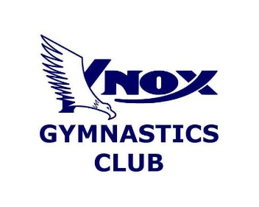

**Speak with us for more information!**

4 Mossfield Avenue

FERNTREE GULLY, VIC, 3156

**P** (03) 9758 1089

Emergency

OUT OF OFFICE HOURS–

9753 6835

[**info@knoxgymnastics.org.au**](mailto:info@knoxgymnastics.org.au)

[**www.knoxgymnastics.org.au**](http://www.knoxgymnastics.org.au)

Stay up to date!

[www.health.gov.au/](http://www.health.gov.au/)

[www.vic.gov.au/coronavirus](http://www.vic.gov.au/coronavirus)

<https://sport.vic.gov.au/>

<https://vic.gymnastics.org.au/VIC/News/COVID-19_Updates/VIC/COVID-19/Updates.aspx>

[www.knox.vic.gov.au/coronavirus](http://www.knox.vic.gov.au/coronavirus)

Listen to your Coach

* Cover your mouth if you sneeze or cough
* Keep 1.5 distance
* Regularly wash your hands
* Face masks are mandatory for indoor settings
* Stay home if you feel unwell

Remember