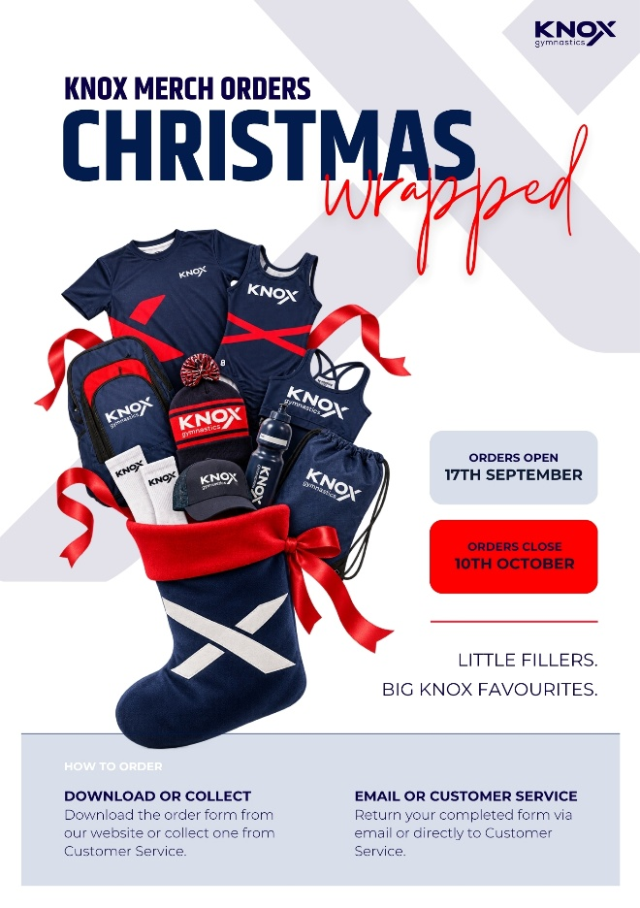
2026 Knox Merchandise Order Form
ORDERS CLOSE 10th October 2026

Athlete’s Name:

Class:

Day:

Time:

Coach:

Item and Size

Training T-shirt Program ………….. Size………… $45.00

Training Leotard(limited stock) Size…………………….. $70.00

Backpack with Name (enter name) …………………….. $65.00

Knox Crop Top (racerback or thin straps) Size…………………….. $50.00

Knox White Crew Socks(size 7-9.5) Size…………………….. $18.00

Drawstring bag $30.00

Beanie $22.00

Truckers Cap $22.00

Drink Bottle $12.00
All Classes welcome to purchase

50% deposit required to place order and balance on delivery

Charge my deposit to my account on file (circle)

Administration use only

Total Cost $

Deposit $

Date Paid:

Staff:

